Centropa Lesson Introductory Information
Overview Information: Borders and Bridges: Human Rights and The Fall of Communism
Ellen Davis, Ramblewood Middle School
Civics (with historical emphasis)
Middle School level: 6th-8th Grade
Requires 3-4 55 minute periods

Lesson Summary
Themes:
The theme of this lesson is Borders and Bridges and how they have impacted Human Rights since World War II. In addition, the lesson will crystallize the idea of what it means to be human and the idea of human rights as per the 1948 Declaration of Human Rights.

Goals:
- Students will be able to define what it means to be human.
- Students will relate human rights to human needs.
- Students will have a basic understanding of the Universal Declaration of Human Rights.
- Students will be able to locate places with Human Rights concerns.
- Students will be able to describe incidences of Human Rights concerns.
- Students will be able to evaluate events of 1989: The Important Dates
- Students will be able to define “war crimes.”
- Students will be able to explain how barriers have encouraged Human Rights concerns.
- Students will be able to demonstrate how bridges can be built to help in incidences of Human Rights concerns.

Materials:

- Handout: Universal Declaration of Human Rights - abbreviated version (see page 6)
- Glue and scissors
- Old newspapers and magazines with lots of images
- Large pieces of roll paper (enough for the class to have one piece per group of 3 or 4 students)
- World Outline Map
- Colored pencils
- Computer with internet capability

Centropa materials:
Centropa Video Links:
Family → “Laszlo Nussbaum: Europe without Borders”
https://www.centropa.org/node/45289
History→ “Maps, Central Europe and History”
https://www.centropa.org/centropa-cinema/maps-central-europe-and-history

Other Resources:
Videos of the Cold War coming soon.

Artifact/Document:
https://www.un.org/en/sections/universal-declaration/human-rights-law/
https://eu.usatoday.com/story/news/world/2018/05/24/border-walls-berlin-wall-donald-trump-wall/553250002/

Teacher Resources:
https://drive.google.com/file/d/1-kNE8U0BzwS48jTOOhDbZC9IA9FNYtkq/view?ts=5d25f9f7 (used for days 1-2)

Background Information
1. Context for Lesson
2. Enduring Understanding

3. Goals/objectives:

4. What Centropa or other sources were used? *See above.
5. Are there any specific background skills or knowledge students need to successfully
learn the concepts, information and skills in your lesson? Students may need a basic knowledge of 20th Century History and forms and systems of government and economies, which will be taught in class prior to this lesson.

The Lesson
This is the road map for teachers wanting to use your lesson in their classes. Include the following:
1. Motivating the students. As students enter the classroom, a paper wall is constructed (hanging from the ceiling or set up in between desks down the middle). Students will sit in their regular seats, regardless of where the wall is.
To get kids interested, they will be invited to figure out why the ‘government’ (the teacher) decided to set up the division and how both sides can be observed (class discussion, 10-15 minutes). As a challenge opener, each student will be given a post-it and invited to attempt to get a message to another student across the wall, thinking in particular about what information will go in the message. These post-its will be shared on the white board for a discussion after the wall ‘comes down’ (20 minutes). With a column notes section on the board or on paper, allow students to then give words for how they felt with the fence up and with the fence down (10 minutes) and discuss.
Homework: Pack a bag in 15 minutes or less with the most important things you need to take with you as you work to make an escape. Limit is one backpack you can carry on your back. Take a photo of all the objects together and email to the teacher.

2. The lesson.
Activity 1: What Does It Mean to Be Human? (approx. 30-45 minutes)
Procedure:
Before you begin this activity, create groups of 3-5 students each for this project. Distribute one sheet of roll paper
per group.
1. Trace Body. Ask for one student to volunteer per group to be traced. Have him or her lie flat on the paper while
another group member traces the outline of their body. Use pencil and then when the outline is done and the

person stands up, have a different student outline in dark marker so that it’s visible. This is a brave teacher mo-
ment as this is chaotic but the kids will love it!

2. Name Character. Ask the group to name their character. Write his/her name on the paper somewhere so oth-
ers can see. When all groups have named their “person”, pass out the scissors, magazines, newspapers, and

markers.
3. Human Being Collage. Tell the class that each group will be searching through the magazines and newspapers
for images and or words that they feel answer the question, “What does it mean to be human?” For example
they may find words like free, equal, think, work, or having opposable thumbs. They also may find images of
a child learning or someone smiling. Have students cut them out and place them on top of their person. They
may use glue or paste but don’t fill in the entire person yet. Leave a blank space about 2 x 10 in. somewhere
on the collage that will be explained later in the lesson.
4. Share. Now get the attention of the entire class and have each small group share one item that they thought
represented the word “human.” Generate one answer per group and write each on the board for the rest of the
class to see. Now ask the students to return their focus to their “person” and their small group. Write the words
“human rights” on the board. Then ask the students if they know what the words “human rights” means to them.
Generate a few ideas and write them on the board if you choose as you will define this more in the following
activity.

Activity 2: Small Group Discussion. Defining Human Rights and Responsibility (approx. 30-45 minutes)

1. Define. Divide students into groups of three or four. Provide the groups with a large piece of paper and a mark-
er, and ask each group to come up with a definition for human rights in their own words. Once they have finished

brainstorming, they should write their definition on the large piece of paper. Post these definitions around the
room. Encourage students to suggest any other human rights they can think of, and include these rights in the
list on the board. Distribute the UDHR list at this point. Write a collective definition of the combined student ideas
on the board or in a place visible to all. For example, “human rights are guaranteed to every person simply by
being human.” Or, “human rights promote basic standards of living equally, with respect and in dignity.” Discuss
the reason for the creation of the UDHR in 1948 and emphasize that is was the first international agreement
made to protect people from inequality and oppression.
2. Human Rights Collage. Assign each group one of the human rights listed on the board, or allow groups to
choose the human right that interests them most. Choose five or six rights that will be easily understood by your
students. Tell students to resume cutting images and/or words from their stack of magazines, now focusing on
words and images relating to their assigned human right. They may also use the markers or crayons to write
related words. Encourage students to be creative in finding words and images that connect to their right. For
example, the right to education can include images of books, pencils and papers, schools, or young people.

The right to health can include images of medicine and hospitals or people leading a healthy lifestyle. Each hu-
man right is broad and touches on multiple aspects of a person’s life. Encourage students to fully explore their

assigned right.
3. Name and Display. Once students are finished, ask them each to write their assigned right in the blank space
on their collage from Activity #1. Display the human collages around the room, in the hallway or another visible
place. They will be used again later in this lesson.
4. Regroup and Discuss. Direct students to look at the human rights depicted on the collages around the room.
Once they have looked for a few minutes, ask the following questions:
• Which of these rights are necessary for survival? How are needs and rights related?
• Which of these rights are necessary to live in dignity?
• What would happen if you had to give up one of these rights?
• Can you think of any other human rights essential to living in dignity?
• Do you disagree with thinking of any of these things as a right? If so, explain your reasoning.
5. Explain. Explain to your students that they have a responsibility to respect the human rights of others and
themselves. Ask students to share ideas about how they can express their understanding of the responsibility
in upholding the rights of others and claiming rights of their own. For example, you may say “Every child has the
right to an education. As a student in this class I am responsible for making sure I work to the best of my ability
and ask for help if I don’t understand something.” Or a student may say “I am responsible for others in my class
and will respect others’ right to an education by not interfering in their learning by talking too much.” You may
want to mention bullying, and discuss how respecting the human rights of others involves being responsible
and standing up against those who bully.

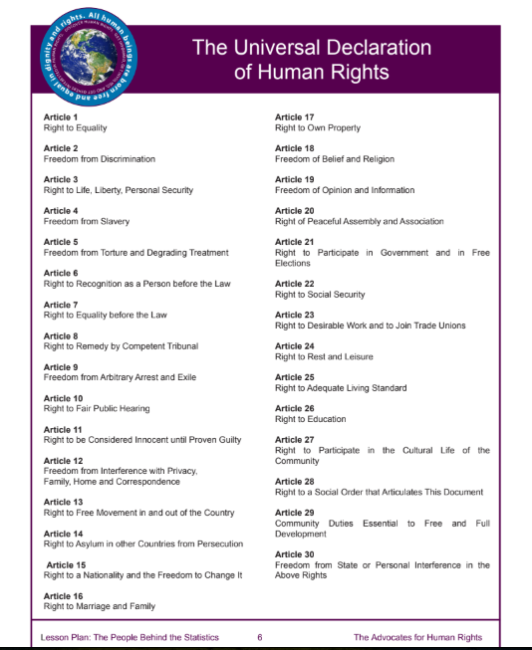

Activity 3: days 3 and 4
1 Watch the following videos, and discuss in class: Coming soon
and https://www.1989.centropa.org/1989-the-film

2. Students will view the timeline at https://www.1989.centropa.org/timeline
3. In their small groups, they will evaluate 2-4 events of 1989 (and do additional research as needed) to connect the Universal Declaration of Human Rights to the events of the fall of Communism.

Day 4-5
1. Present students’ findings
2. Evaluate current world issues (i.e.US border wall with Mexico and detention centers, crisis in Venezuela, Myanmar, Hungary, etc. and look at past events (i.e. Bosnian, Armenian, Rwandan Genocides and Stalin’s Forced Famine) as examples of Human Rights violations. This will be done as a class discussion.
3. Locate these places on a world map.
4. Wrap up and discussion:
- How do borders impact human rights?
- How can bridges be built to impact human rights?

