LESSON PLAN
A.TITLE: Escape from Prague
Course the lesson taught in : History- English
Primary Category : Post World War II Europe
Grade level of students: Adaptable according to the classroom sudents
Total hours required : 3-4 fifty minutes lessons.

B. Summary
1. Describe characteristics of the Cold War.
2. Examine causes, course, and consequences of the early years of the Cold War
(Truman Doctrine, Marshall Plan, NATO, and Warsaw Pact).
3. Spot history changes in Prague after the World War II through the Centropa
film (https://www.centropa.org/node/47756) and the impact of the 1989
events.

C. Background information
1. It serves as an introduction to understanding the Cold War and the fall of
Communism in Europe.
2. It enables students to realize the continuation of history since 1945 till today.
3. A Centropa film was used and a British political cartoon of 18 June 1947 by EH
Shepard for the British magazine “ Punch”
4. The learning goal is to describe the tensions and origins of the Cold War and
the impact of World War II and its consequences to the European countries.

D. The Lesson
1st Step
Introduce students to the topic of the Cold War by asking them what they think the term “Cold War” means. How is a “cold” war different from a regular war? (15 min)

2nd Step
Then, show the political cartoon depicting Truman and Stalin as two taxi drivers and ask students to think about what the cartoon tells them about the Cold War era. Finally, ask students to brainstorm what they already know about the Cold War. (25-30min.)

A British cartoon of June 1947 shows Truman and Stalin as two taxi-drivers trying to get customers. The 'customers' are labelled 'Turkey', 'Hungary', 'Bulgaria', and ‘Austria’.
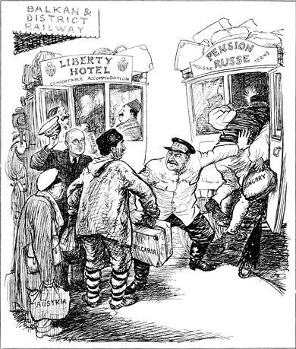
- Who are two central figures?
- What are they doing? Describe the conditions of the two taxi cars.
- Who do the passengers depict?
- What is the message of the political cartoon?

3rd Step
Review key events during the early Cold War years .Afterward, assign pairs of students to one of the following terms for which they will create a digital vocabulary poster using www.postermywall.com. : Iron curtain, Truman Doctrine, Marshall Plan, NATO, Warsaw Pact. (45 min)

4th Step
View the film as a class and assign students in groups to take notes of the historical events conveyed through it while watching. Group A will take notes about the events and everyday life in Prague before 1989 and Group B will take notes about the events after and the adult life of our hero after 1989.

Concluding activity
Students in their previously separated groups create a word splash that displays the general ideas of Cold War and the fall of the Berlin Wall in 1989.

Materials used
1. A Centropa film https://www.centropa.org/node/47756
2. A British political cartoon of 18 June 1947 by EH Shepard for the British magazine
Punch.

