Title: Kindertransport: Shaping Identity
Names: Caryn Weingast, Andrea Sertic, Andy Schuh, Lena Soltendieck, Roni Baron
Course: Holocaust, English, History, Social Studies, Human Studies
Middle / High School 12 - 18
Timing: 70 - 90 minutes

Summary: This lesson fits into broader themes of coming of age and development of self identity and elimination of preconceptions of Jewish people by presenting relatable personal stories. Students will be able to identify how the kindertransports affected the sense of identity for individuals who were removed from their families as well as how their own family impacts their sense of identity. This lesson makes use of the Kindertransport videos “A Suitcase Full of Memories” and “Kitty Und Otto Suschny - Only a Couple of Streets Away from Each Other”. This lesson is appropriate for middle school and high school students.

Context: This lesson fits into broader themes of coming of age and development of self identity

Enduring Understanding:
- Children develop a sense of self based on the people around them. The removal of children from their families by the Kindertransports affected children’s sense of identity.

Goals/ Objectives
- Students will identify how the kindertransports affected the sense of identity for individuals who were removed from their families.
- Students will be able to identify how their own family impacts their sense of identity.

Resources:
DEPENDING ON YOUR CLASSROOM RESOURCES YOUR STUDENTS MAY NEED TO BRING IN THEIR OWN EARBUDS AND USE THEIR PHONES TO WATCH THE VIDEOS
- Kitty and Otto Suschny
- Suitcase full of memories
- Lesson extension and other resources:
  - Other Kindertransport survivors
  - “Zero” background builder video
  - Kurt Brodman - The story of the Brodman Family

Background skills or concepts:
To ask and respond to questions critically both orally and in writing
To compare and contrast stories of Kindertransport survivors
To make personal connections to survivors’ experiences
Lesson Outline:
- Motivating the students: Choose one of the following: (5 - 10)
  - Word analysis / discussion - Kinder Transport
    - Project the word Kinder on the board. Ask a student to read the word, correct the probable mispronunciation and explain that that this is a German word. Then ask students what they think the word means. Ask them what word or words they know that have the word Kinder in it, ex. Kindergarten. What is kindergarten?
    - Then project the word Transport? Ask students what transport means?
    - Next project Kinder Transport and ask what they think that might be.
  - Exploring a picture through Thought bubbles
    - Project the picture ( Kindertransport children:) and ask the students to talk to their partner and each pic out one person and think about one thought the child may have and one thing the child may say. ( You can also give them a thought and a speech bubble each so they can write inside it.) the students then walk around the class and share their ideas and thoughts.
    - This activity gets the students interested in what might have happened as well as forming a personal connection with the people in the pictures.
    - These hypotheses can be revisited later and changed or critically reflected upon. Depending on how the students react(ed) to it.
  - Berlin Memorial Photo discussion
    - Show the pictures and/or the video to the students. You can reflect on the pictures using the questions and/or have the students reflect on the images without asking them anything.

- Lesson:
  - Divide the class into two focus groups who will each watch one of the kindertransport videos and take notes from guiding questions (see worksheet) Divide the focus groups based on individual abilities as “Suitcase” is 30 minutes and “Kitty and Otto” is 12 minutes so that students who may need to rewatch will have time. Use the last ten minutes for students to compare and confirm their group’s results. Students who watch Kitty and Otto’s story may be given an additional video from resources above to ensure they finish around the same time. Students with a shorter video may also research a term from the list. (40 min)
  - Jigsaw groups to compare their people and record what they’ve learned (10 min)
Mix students from both focus groups so that students can teach each other and record information about their corresponding video (poss. Venn diagram style). After students have shared their learning about Lilli / Kitty and Otto they are ready to move to the next step.
  - Self Reflection through what if and How is questions (10 min)
Individually students respond to the following questions and share with a group partner.
- What if you had to grow up in a different place away from your family?
  - What would you miss the most? What would you try to take with you? (no cell phone)
- How would you feel if you had to leave your current life behind?
  - How would you cope with the loss?
You may find that other questions will help students reflect more personally or connect with the videos. Adjust as necessary.
- Closure: (10 - 15 minutes)
  - Write a journal entry explaining how learning about the kindertransport’s effect on the individual coincides with the impact your family/your biography has had on your own sense of self.

International exchange (option):

The products and further activities such as the personal reflections can be shared with different classes (connections made through CENTROPA)
The products need not be shared at the same time, but can be revisited and in that sense also be reflected upon again.

Intro Activities:
Picture with thought bubbles
Example for the introduction task: picture. Other pictures may be selected from the Centropa website
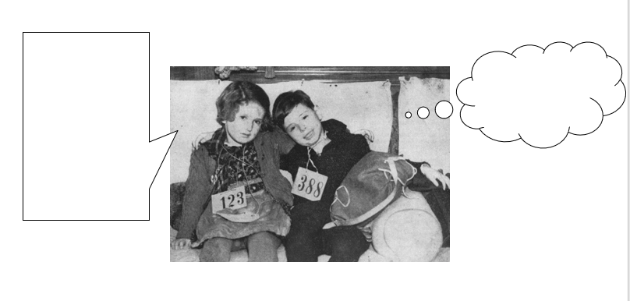
https://www.kindertransport.centropa.org/?lightbox=dataItem-jwrrmers

KinderTransport Memorial - BERLIN
Frank Meisler’s Kindertransport memorial (2008) near Friedrichstrasse Railway Station, Berlin

Video

Questions for images:

What do I see?
What objects do you see?
What is missing ?
Colors, age, number of people, direction

The title of the Statue is :
Trains to life
Trains to death

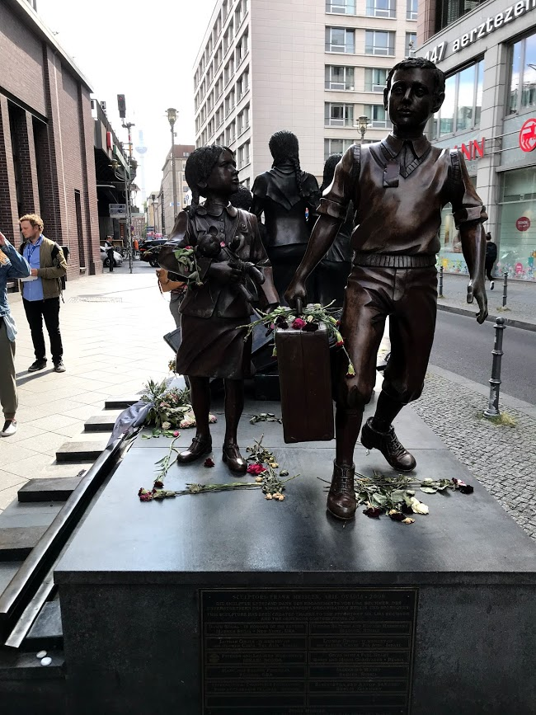

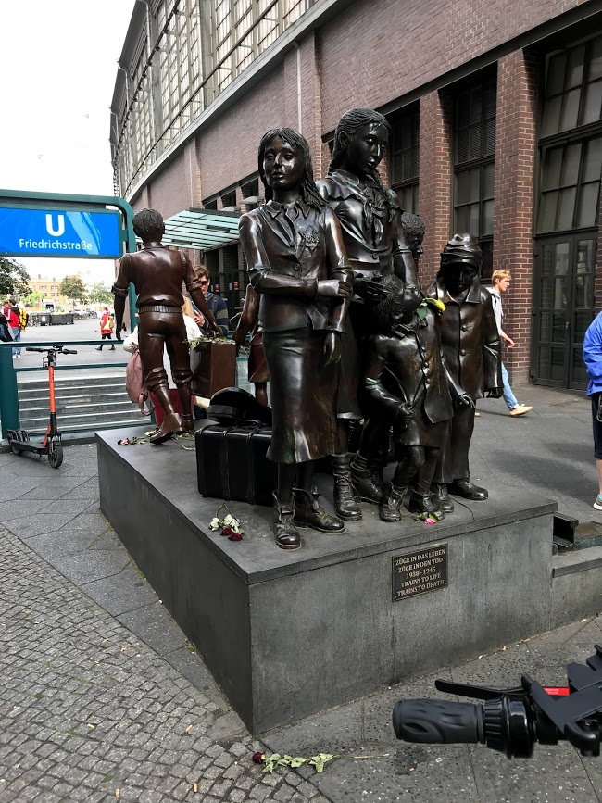

Potential questions for “A Suitcase of Memories”:
- What was the purpose of the train?
- How old was the girl?
- How did the young girl feel at the train station? How did her parents feel?
- Where was Lilli from?
- What did her family do before the war?
- When did Llli first experience anti-semitism?
- How did her life change?
- Her older brother was not the part of Kindertransport. Where did he go?
- What number was assigned to Lilli?
- How long did it take Lilli to get to London? Where did she go from there?
- Lilli was able to communicate with her parents by writing letters. What were some things they wrote to each other about?
- After WWII started how were the letters Lilli and her parents sent to each other getting through?
- What did Lilli do to distract herself from thinking about what was happening around her?
- When was she no longer able to write to her parents?
- What organization did Lilli join? What did they do?
- When did she first think that her parents may no longer be alive?
- When did she return to Vienna?
- Aunt Bertie have her a suitcase her parents left behind. What did it contain?
- Through letters and pictures Lilli’s father told aunt Bertie about life in the ghetto. What were some of the things he described?
- What was her father’s New Years wish in 1941?
- Where did her parents go after being deported from the ghetto?
- Did her parents survive?
- How did Lilli feel when she returned to her hometown?
- When did Lilli realize how strong her parents were to send her away?
(After Video)
- Speculate on / discuss the difficulties Lili had experienced after being transferred.
- How do you think her life might have been different without the Kindertransport?
- How did her life in London and the countryside affect her identity?
- Speculate on / discuss the impact of Lili experience on her identity.
- Discuss possible reasons for Lilli not wanting to stay in Vienna.
- Discuss the use of voice-over and pictures in the movie: how do they contribute to the story telling?

Potential questions for “Kitty und Otto Suschny”

- Where did Kitty and Otto Travel to before the war?
- What do you learn about Kitty’s brother?
- What do you learn about Otto’s father?
- What was Kitty’s father’s job? What did her mother do?
- Describe Otto’s elementary school experience.
- How did life change after the Nazi Germans marched into Vienna:
  - In school-
  - Around town-
- Describe what happened on the 9th of November 1938.
- Why did Kitty’s mother think they were safe?
- How did Harry escape?
- How did Kitty escape?
- What stands out to you most about what Kitty says about the Kindertransport?
- How did Otto get to Palestine? Why?
- What happened to Otto’s father?
- What happened to Kitty’s mother?
- Describe Kitty’s experience upon arriving in England.
- Kitty says, “Let’s go to the dog and pony show,” what does this reveal about her feelings regarding the kinder transport.
- Describe Kitty’s life in Southport.
- What did Kitty and Ilse do in Manchester?
- Describe Otto’s life in Palestine. And Italy.
- What do Kitty and Otto learn about their parents?
- Describe Kitty’s return to Vienna. Otto’s return to Vienna.
- How did they meet? How long did it take before they got married?
- Describe their life after getting married.
(After Video)
- How do you think their lives might have been different without the Kindertransport?
- How did her life in Southport and Manchester affect her identity?
- Speculate on / discuss the impact of Kitty and Otto’s experiences on their identity.
- Discuss possible reasons for Kitty not wanting to return to Vienna.

Researching - Optional
- Choose one term, read about it and write a short description:
Kindertransport, Gestapo, Krisallnacht, Concentration camp, Ghetto, Death camp.

