Title: A Friend in need is a Friend Indeed!!!
Team members: Gulben Gungor, Hristina Miteva Tanaskoska, Laura Allen and Maja Stojanovska
Course: ESL, Language Arts (Can be taught in other courses)
Category: Civic duty through English lexicology
Grade level: 6th/7th /8th
Ages: 11-13
Required time to teach the lesson: 70 minutes

Personal information about us:
Gulben Gungor has been working as an English teacher and educator for 20 years now and currently she works in Istanbul in Uus Jewish School.
Hristina Miteva Tanaskoska has been working as an English teacher for 11 years now and currently she teaches in an elementary school in Kochani, Macedonia.
Laura Allen has been teaching for 10 years now and currently teaches 7th grade in Sylva, NC, USA in an elementary school.
Maja Stojanovska has been working as a teacher for 9 years and currently she teaches in an elementary school in Skopje, Macedonia.
Summary: Students will be completing an activity called the Universe of Obligation where they will determine who they feel the most obliged to. We will then discuss the results of the activity which will serve as a warm up. Students will then watch the film Return to Rivne which will be shown in three parts with time allowed for discussion between each section. Students will think and/or take notes about the Universe of Obligation during the film. Students will provide feedback. After the film, students will post their opinions on Padlet or will record a video to share with the class. Optional activity could be creating a community service project.
Background information
1. Context for lesson: Literature and documentary films
2. Enduring Understanding (EU) – What we want to get across to our students is the idea of change and how life can be uncertain and how people can come across challenges and hardship. In addition to this, we hope to encourage students to empathize with others and embrace their civic duties.
General objectives:
-to teach students equity
- to encourage students to cooperate and participate in class discussions
-to raise awareness of the notions such as tolerance, responsibility, doing the right thing
-to enhance students’ sense of moral and ethical responsibility
-to bring closer the theme of Holocaust

Language objectives:
-to develop listening and speaking skills through watching a short CENTROPA film
-to broaden students’ vocabulary
Resources
The short film, Return from Rivne’’ from the CENTROPA website, thttps://www.centropa.org/centropa-cinema/return-rivne-holocaust-storyhe
“Universe of Obligation” https://www.facinghistory.org/holocaust-and-human-behavior/chapter-2/universe-obligation
Map of Ukraine and a World Map
Film Script
A certain level of knowledge in ESL and optionally a prior knowledge of the theme of Holocaust

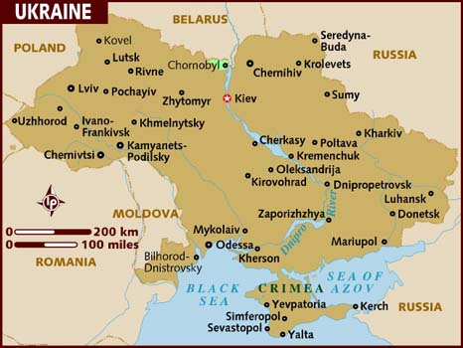

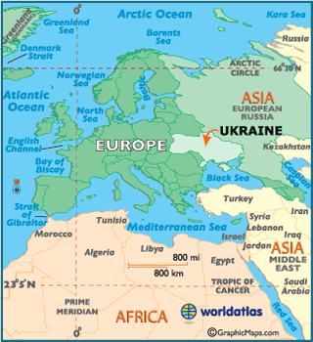

The Lessons
Motivation and warm activity: Universe of Obligation (20 minutes)
In Circle 1, write your name.
In Circle 2, write the name of people to whom you feel the greatest obligation – for
example, people for whom you’d be willing to take a great risk or put yourself in peril for
(you don’t have to write actual names.)
In Circle 3, who are the people on the next level? That is people to whom you have
some obligation, but not as great as in circle 2.
In Circle 4, who are the people on the next level? People to whom you have some
obligation, but not as great as in circle 3.

Student Discussion Questions:
This could be a verbal discussion or a written response
How did you decide who would be placed in your circle?
- Why do you feel an obligation to the people in the second circle?
- How did you decide who would be in Circle 3?
- Who are the people on the outside of the circle, and why did you put them there?

This discussion will lead us to help students understand who is the most important to them. Circle two are the people with whom we can easily identify while the outer circles are people or groups in which we do not identify or groups that we are not part of.

Film Overview: The film “Return to Rivne” is a true story of two young girls and their mothers who were hidden during the Second World War. (50 minutes)

- Prior to watching the film we will show the students a map of the Ukraine and help them to visualize where the story is taking place. While watching we would like the students to focus on the universe of obligation that was completed at the beginning of the project, and think about the characters throughout the film, Students may take notes or draw the universe of obligation figure and fill it out while they watch.
The film will be watched in three segments followed by discussion after each section. The video is 22 minutes long.
- Life before the war ( 2.25 minutes) Discussion will be 5-10 minutes
- Life during the war ( 13 minutes) Discussion 5- 10 minutes
- Life after the war ( 7 minutes) Discussion 5 -10 minutes

Life before the war: Student are instructed by their teacher to pay attention to Shelly and Raya’s childhood and make comparisons with their own experiences. We would like for our students to be able to compare their lives to Shelly and Raya’s life before the war to see that their own lives are not any different. Students can empathize with their family life and way of living.

Life during the war: Students will be able to see how quickly life and circumstances can change for better or for worse.

Life after the war: Students will be able to see how difficult it is to rebuild their lives and grasp the idea that their childhood was stolen from them. Understand the concept of loss but also learn appreciation for people who choose to help during a time of need.

Based on their notes from the Universe of Obligation, we will discuss the characters’ universe of obligation and discuss Nikinor and Natalia’s role in their survival.
Shelly says, “I am not sure how I would react in the same situation. I don’t think that many of us know how we would react.”

Student discussion: Bravery, strength, courage. Even though the Palaschuck family was in the last circle on the obligation activity, they still refused to be bystanders and chose to help despite personal risk of losing their own family and having their property confiscated.

Students can share their opinions of whether or not they would have helped on a Padlet. Or they could record a video of themselves sharing their opinion and post it for the class.
Homework/Classwork: Students will look at three other posts from classmates and think about one way they could have helped Shelly and Raya. Optional: students can reach out in their own community and see if they can volunteer and help others in need. Students could create a community service project and pitch the idea to their teacher and classmates.

