“Should I be Worried?” Holocaust Precursors vs. Modern Events

Overview information
- Names/institutions:
Monika Anuszkiewicz - School Complex number 2 in Leszno (Poland);
Mark Hoffman - Mountain Lakes High School (USA);
Magdalena Płoszaj - Auschwitz-Birkenau Museum Memorial (Poland);
Ron Weitman - Techni High School in Haifa (Israel)
- Courses: History, Civics and Literature
- Category: Pre-war life, genocide/atrocity precursors
- Grade: high school or middle school
- Time: 90 minutes lesson + time for students homework + summary lesson

Summary: The aim of the lesson is to encourage students to think about precursors of past atrocities and compare them to events in their country today. They will use Centropa films and testimonies, as well as non-Centropa images, to describe ONE example of discrimination in pre-Holocaust Germany and Austria before the Nov. 1938 pogrom, followed by their own research concerning a contemporary discrimination event or trend. This leads the student to reach their own answer to the question, “Should I Be Worried?”

Specific Centropa materials:
  - Film: Erna Goldman "From Frankfurt to Tel Aviv"
  - Film: Kitty and Otto Suschny "Only a couple of streets away from each other”
  - Film: Leo Luster "The past is another country"
  - Film: Kurt Brodmann "The story of the Brodmann family"
  - Centropa Kristallnacht Website https://november1938.at/en/
  - Lilly Tauber interview https://www.centropa.org/biography/lilli-tauber

Specific non-Centropa materials:
- Front page from Der Sturmer; https://encyclopedia.ushmm.org/content/en/artifact/der-stuermer-number-29-july-1934
- Clip of Hitler speech against Jews; https://www.ushmm.org/learn/timeline-of-events/1939-1941/hitler-speech-to-german-parliament
- Photo of a Jewish woman sitting on a bench marked “for Jews only,”: https://www.ushmm.org/online-calendar/event/mahateimpctdc0319
- Examples of Nazi propaganda posters: https://www.ushmm.org/information/about-the-museum/museum-publications/memory-and-action/why-we-need-to-study-nazi-propaganda
- Photo of SA picket stands in front of the Jewish-owned Tietz department store: https://collections.ushmm.org/search/catalog/pa3867
- Examples of Nazi propaganda posters: https://www.ushmm.org/information/about-the-museum/museum-publications/memory-and-action/why-we-need-to-study-nazi-propaganda

Context for Lesson: Lesson could be arranged as an introduction to a Holocaust course or human/civil right course or even modern history course.

Outcome: Students will evaluate similarities and differences between ONE precursor of the Holocaust and a modern parallel in their own country.

Enduring Understanding: Students can judge the extent to which a discrimination event or trend happening today may or may not be something that could lead to atrocities.

No specific prior skills or knowledge needed for this lesson.

THE LESSON PLAN

Warm up (10-15 minutes)
- Optional soft introduction: “If I knew then what I know now...” - turn to a neighbor and discuss an example from your life. Hopefully, this will get students to think about how things are clear in hindsight, but not clear at present.
- Ask students to brainstorm: what types of groups are subject to discrimination in their own country?
Teacher could start with images to spark ideas, or not
Discussion as full class or groups
Teacher guides class discussion toward the following list:
race, religion, sexual orientation, immigration status, national origin etc
3. In what ways do people and governments discriminate against those groups?

Lead discussion to preselected list of discrimination actions below:

Discrimination Precursors:
- Government communications / propaganda targeting a group (racial/ethnic, religious, sexual orientation, disability, etc.)
- Popular press / other media targeting a group
- Public protests against group
- Hate speech / vandalism / graffiti
- Social discrimination (bullying biased on victim group)
- Legal discrimination
- Restrictions on immigration / emigration
- Family separations (parents sending children away for safety, etc.)

Terminology (5 minutes)
Define for students the word, precursor:

Something that precedes and indicates the approach of something else

Emphasize for students: it doesn’t ALWAYS lead to the next thing, but it CAN lead to it, and is necessary for the next thing to happen.

Explain Student task #1 (5 minutes)
Using Centropa sources below, find examples of Jews in Germany (and, to a lesser extent, Austria) who experienced early signs of discrimination against them as Jews. These should be from January 1933 (Hitler takes power) to November 1938 (Kristallnacht, or “November pogrom”). Encourage / require students to read full testimony and see full video for each resource, with focus on the segments noted below:

Show sample research resources (20-30 minutes)
Centropa resources:
Erna Goldman "From Frankfurt to Tel Aviv"; https://www.centropa.org/centropa-cinema/erna-goldmann-frankfurt-tel-aviv?subtitle_language= 4:50-7:25 she was excluded from her university

Kitty and Otto Suschny "Only a couple of streets away from each other”
https://www.centropa.org/centropa-cinema/only-a-couple-of-streets-away-from-each-other. 3:00 - 3:45 Jewish teacher was suddenly removed after Anschluss, School Director screamed at Jewish students, couldn’t enter park labeled “Aryans only”

Leo Luster "The past is another country"; 2:55-5:25; losing stores, jobs, people arrested, thrown away from their homes, not allowed to go to parks
https://www.centropa.org/centropa-cinema/leo-luster-die-vergangenheit-ist-ein-anderes-land?subtitle_language=

Kurt Brodmann "The story of the Brodmann family"; https://www.centropa.org/node/52714 2:15-2:44; teacher treating Jewish student unfairly

Centropa “Bullying Stories” https://www.centropa.org/bullying-stories/bullying_overview.html

Centropa Kristallnacht https://november1938.at/en/: quotes on homepage
“Suddenly, we were not allowed to sit on the benches anymore.”
“Wilhelm Steiner was eighteen years old in November 1938 and had to watch how his family’s business was plundered. When he wanted to intervene, he was accused of insulting Hitler and was arrested.

Lilli Tauber interview, especially prewar parts, https://www.centropa.org/biography/lilli-tauber

Non-Centropa materials:
Front page from Der Sturmer
https://encyclopedia.ushmm.org/content/en/artifact/der-stuermer-number-29-july-1934

Clip of Hitler speech against Jews
https://www.ushmm.org/learn/timeline-of-events/1939-1941/hitler-speech-to-german-parliament

Examples of images to use:
Jewish woman sitting on a bench marked “for Jews only,” shortly after the Anschluss, the annexation of Austria into Nazi Germany in 1938. US Holocaust Memorial Museum, courtesy of The Wiener Library for the Study of the Holocaust & Genocide:
https://www.ushmm.org/online-calendar/event/mahateimpctdc0319

An SA picket stands in front of the Jewish-owned Tietz department store wearing a boycott sign that reads: "Germans defend yourselves; don't buy from Jews!":
https://collections.ushmm.org/search/catalog/pa3867

Examples of Nazi propaganda posters:
https://www.ushmm.org/information/about-the-museum/museum-publications/memory-and-action/why-we-need-to-study-nazi-propaganda

Law: “Jews are excluded from sports groups” April 25, 1933

Law: “Jews may not use the public beach at Wannsee” August 22, 1933

Explain Student task #2 (5-10 minutes)
Teacher provides ONE example of a recent (< 2 years old) news article from their own country (see examples below). Students search for a recent news article that aligns with ONE of the precursors listed above. Teacher can divide students into groups or let them work alone.

Optional, if appropriate: instead of, or in addition to a news article, student can describe an incident of discrimination in their own school or town that they are familiar with.

Student or group begins task #2 research in-class using their own internet-linked device.

Example of recent news articles or photos students might find: (the teacher may show one to students as an example)
USA: “Ahead of Massive Weekend ICE Raids, Immigrant Advocates Stage Foley Square Protest” NBC News, July 12 2019

Israel: “Violent protests erupt in Israel over police shooting of unarmed Ethiopian teen” Vox, July 2, 2019

Poland: wSIECI July 2016: “Islam rape on Europe. Our report: What media and elite of Brussels are hiding from citizens of Union.”

Poland, banner at November 2017 national (Independence Day) march:
“Europe will be white or uninhabited”
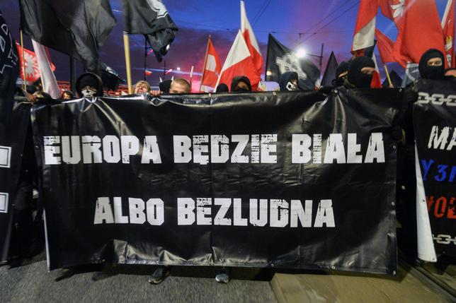

Poland - Warsaw graffiti 2016 “Kill the Jew”
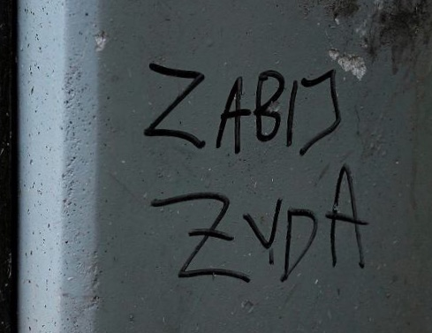

Student Product/Concluding Activity Options:
All student products answer question: “Should I Be Worried?”
- Short presentation to class, describing the Holocaust precursor they identified, the modern event they researched, their answer to the question “Should I Be Worried” and an explanation of that answer.
- Interview another student with different answer to question - defend reasons
- Poster presenting Holocaust precursor and modern event, asking viewer to decide, “Should I be worried?”. Create a class exhibition of all student posters, display to students in other classes, with researchers as guides
- Short (1-2 paragraph) writing assignment summarizing 1930s precursor, modern event, their answer to the question, “should I be worried”, and an explanation of that answer.

Follow-up discussion question (optional)
- About ½ of German Jews left between January 1933 and November 1938
- Therefore, about ½ were VERY worried
- The other ½ witnessed same events and weren’t worried enough to flee - brainstorm reasons

Interdisciplinary options:
- Art teacher to create posters
- Cooperate with English teacher to translate for sharing
- International sharing options between classrooms in two or more countries
  - Share images of poster exhibition
  - Share videos of students discussing what they learned
  - Share questions that students raised after the project, to be answered by students in another country

After students complete their project one more lesson should be conducted in order to evaluate and discuss their “creations”. The form of the lesson depends on the form of the project students are working on.

